A Project Report

AWS BASED SMART HOME USING TELEGRAM BOT

UNDER THE GUIDANCE OF

PROF. PRATIKSHA PATIL

SUBMITTED BY

NIKAT KHAN PRN NO.- 72037352K

MANISHA REDEKAR PRN NO.- 72037382E

AKASH KUMAR PRN NO.- 72037358B

AYMAN ATTAR PRN NO.- 72177713K

IN COMPLETE FULFILLMENT OF THE

REQUIREMENTS FOR THE DEGREE OF

BACHELOR OF ENGINEERING



DEPARTMENT OF

ELECTRONICS AND TELECOMMUNICATION ENGINEERING

KEYSTONE SCHOOL OF ENGINEEERING

(2022-2023)



KEYSTONE SCHOOL OF ENGINEERING, PUNE

DEPARTMENT OF

ELECTRONICS AND TELECOMMUNICATION ENGINEERING

(2022-2023)

CERTIFICATE

This is to certify that final project work entitled “AWS BASED SMART HOME USING

TELEGRAM BOT” was successfully carried by

NIKAT KHAN PRN NO.- 72037352K

MANISHA REDEKAR PRN NO.- 72037382E

AKASH KUMAR PRN NO.- 72037358B

AYMAN ATTAR PRN NO.- 72177713K

In the fulfillment of the undergraduate degree course in final year Electronics and telecommunication Engineering, in the academic year 2022-2023 prescribed by the Savitribai Phule Pune University.

Prof. Pratiksha Patil Prof. R.A. Barapate Principle

Guide Head of Department

Department of E&TC Department of E&TC

Place: Pune External Examiner

Date:

1

ABSTRACT

Technology has changed the world. There is a huge growth in technology connected to almost every field. The pace and diversity of advancement is very rapid. Hence, new technology and techniques are coming up and are use as per the need. In such advanced scenario, providing security to home has also become a major point of concern. Presently security cameras can be used for the same. But such cameras may be visible to intruders and there is possibility that cameras may be damaged. Hence, to serve the purpose, there is a need to find an alternative secure, accurate and quick method. Hence, an effort is made in this paper to design a home security system using Raspberry Pi and AWS.

One of the important aspects in the smart home system is the security capability which can simply lock and unlock the door or the gate. Using CNN architecture and AWS services

This system will monitor when motion detected and checks for the faces in the image captured and with the help of AWS face recognition alerts if the face detected is not stored in the database (Dynamo DB). The output of face recognition algorithm is then connected to the relay circuit, in which it will lock or unlock the solenoid lock placed at the door. Results showed the effectiveness of our proposed system, in which we obtain around 90% face recognition accuracy.

Keywords: AWS Face Recognition, Internet of Things, Image Processing, Air Purifying.

23

2

ACKNOWLEDGMENT

Every orientation work has an imprint of many people, and it becomes duty of author to express deep gratitude for the same.

We would like to take this opportunity to express true sense of gratitude towards our project guide Prof. Pratiksha Patil for her valuable co-operation and guidance that gave us for this project.

We would also like to thank our head of the department Prof. R. A. Barapate for inspiring us and providing us all lab facilities with internet, which helped us with the project work. We would also like to express our appreciation and thanks to all those who knowingly or unknowingly have assisted us & encouraged us for our project.

3

**INDEX**

|  |  |  |
| --- | --- | --- |
| SR.NO. | Contents | Page No. |
| 1 | Introduction | 5 |
| 2 | Literature Survey | 6 |
| 3 | Problem Statement and Objective | 7 |
| 2 | Specifications | 8 |
| 5 | Block Diagram, Description, Circuit Diagram | 9 |
| 6 | Software Description | 15 |
| 7 | Flowchart | 16 |
| 9 | Advantages and Application | 18 |
| 10 | Conclusion | 19 |
| 11 | Future Scope | 20 |
| 12 | Reference | 21 |
| 13 | Workplan | 22 |

4

INTRODUCTION

AWS is known Amazon Web Service and Amazon Recognition Video can detect objects, scenes, faces, celebrities, text, and inappropriate content in videos. You can also search for faces appearing in a video using your own repository or collection of face images.

Recognition provides several computer vision capabilities, which can be divided into two categories: Algorithms that are pre-trained on data collected by Amazon or its partners, and algorithms that a user can train on a custom dataset which will be used as Security Measures.

AWS IoT makes it easy for you to build scalable IoT applications that collect, process, analyse, and act on data generated by connected home devices without having to manage any infrastructure.

Using AWS IoT, you can enable any device to connect to the Internet and perform a desired action quickly, reliably, and easily. These devices can work alone or together with other devices or hubs for an integrated smart home experience.

Raspberry Pi is a microcomputer development board that can be used to make Do It Yourself (DIY) projects on the Internet of Things (IoT). Over here, we are using a Raspberry Pi board along with the relevant modules and switches to create a smart home automation project.

Nowadays the air condition is very polluted. In recent years, car emissions, chemicals from factories, smoke and dust are everywhere. That is the reason why now air condition is very polluted. The effect of air pollution is very bad for our health, especially for place where the air in our body is taken for breathing. In our lungs may cause some diseases, such as asthma, cough, lung disorders.

Air Quality Monitoring and Improvements is necessary as degrading air quality has been a matter of concern nowadays and real time monitoring of air quality helps us to keep a check on it and improve it using Ionizer.

5

Through Telegram bot we fire a command and get the desired output.to make it simple in Telegram bot is also developed where we can ON and OFF light through this messenger. To make it user friendly Telegram bot is used.

6

LITERATURE

Dhiraj Sunera and Veena, Iot and chatbot Implementation of interactive home automation systems based on email and Bluetooth technologies in year 2015.[1]

Somphop Chanthakit, Choo pan Rattanapoka, Internet of things, MQTT, Air quality, Sensors, Node-RED, ESP8266 NodeMCU MQTT Based Air Quality Monitoring System using NodeMCU and Node-RED year 2018.[2]

G. Venkat Ramana, Face recognition and raspberry pi Webpage And Telegram Bot Controlled Home Automation System Using Raspberry Pi3 in year 2021.[3]

Sharma, Harish Kumar and Sharma, Mayank, Home Security, Raspberry pi, Motion detection. IoT Based Home Security System with Wireless Sensors and Telegram Messenger in year 2019. [2]

S.Muthukumar, W.Sherine Mary, The system was based on using PIC16F877A microcontroller which took information from sensors and sent it to Wi-Fi transceiver. IOT based air quality monitoring and control system in year 2018.[5]

Rohan Kumar Jha Air Quality over an IOT analytics platform - Thing Speak using internet connected with the hardware via the Wi-Fi module ESP8266. Air Quality Sensing and Reporting System Using IoT in year 2020.[6]

Neha Patil, Shrikant Ambatkar and Sandeep Kakde Web camera, Wi-Fi module, Raspberry Pi, IoT based Smart Surveillance Security System using Raspberry PI in year 2017. [7]

Dongyun Wang,Chenglong Jiang,Yongping Dan, The system used LM3S8962 gateway and ZigBee technology to monitor the air quality data. Design of air quality monitoring system using internet of things in year 2016.[8]

P.Amith Teja , A. Anne Frank Joe, V. Kalist, Internet of things, Raspberry Pi, PIR sensor, IR sensor, Home security. Home Security system using Raspberry Pi with Iot in year 2021. [9]

7

PROBLEM STATEMENT & OBJECTIVE

PROBLEM STATEMENT:

To implement the smart home using AWS and Telegram Bot.

OBJECTIVE:

1. To build a door lock system using AWS
2. To monitor air and control
3. To build a telegram bot for managing smart home

8

SPECIFICATIONS

2.1 HARDWARE

1. RASPBERRY PI
2. ESP32 CAM
3. DHT 32
4. MQT
5. ZERO PCB
6. RELAY
7. CAPACITORS 0.1uf
8. DIODES
9. RESISTORS
10. LED
11. PIR SENSOR
12. LCD
13. BUZZER

2.2 SOFTWARE

1. AWS FACE REKOGNITION
2. PYTHON
3. RASPBIAN

9

BLOCK DIAGRAM

**Raspberry Pi 3B+**

**DHT22**

**ESP32 CAM**

**IONIZER CKT**

**PIR Sensor**

**Solenoid Lock**

**MQ7**

**LCD DISPLAY**



10

DESCRIPTION

1. Raspberry Pi

SD Card Slot is used to install OS/booting/long term storage. The total memory SD card is about 2GB.

1GB RAM.

Micro USB Power Port provides 700mA at 5A.

RCA Video Out is connected to display if HDMI output.

Ethernet Port is used to connect to the Internet.

HDMI OUT (High-Definition Multimedia Interface) is used with HDTVs as well as monitors with HDMI input.

GPIO 20 pin interface allows us to control and interact with real world.

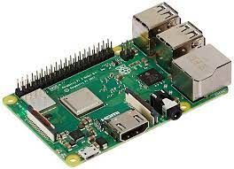

2. PIR Sensor

A **passive infrared sensor** (**PIR sensor**) is an electronic sensor that measures infrared (IR) light radiating from objects in its field of view. They are most often used in PIR-based motion detectors PIR sensors are commonly used in security alarms and automatic lighting applications.

PIR sensors detect general movement, but do not give information on who or what moved. For that purpose, an imaging IR sensor is required.

111

A PIR sensor can detect changes in the amount of infrared radiation impinging upon it, which varies depending on the temperature and surface characteristics of the objects in front of the sensor.[[](https://en.wikipedia.org/wiki/Passive_infrared_sensor#cite_note-Glolab_Corporation-2)

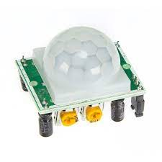

3.ESP 32 CAM

The smallest 802.11b/g/n Wi-Fi BT SoC module

Low power 32-bit CPU, can also serve the application processor

Up to 160MHz clock speed, summary computing power up to 600 DMIPS

Built-in 520 KB SRAM, external 2MPSRAM

Supports UART/SPI/I2C/PWM/ADC/DAC

Support OV2620 and OV7670 cameras, built-in flash lamp

Support image WIFI upload

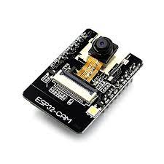

4.DHT 22

The DHT 22 is a low-cost temperature and humidity sensor. It uses a capacitive humidity sensor and a thermistor to measure the surrounding area and spits out a digital signal on data pin.

3 to 5V power and I/O 2.5mA max current use during conversion (while requesting data)

12

Good for 0-100% humidity readings with 2-5% accuracy

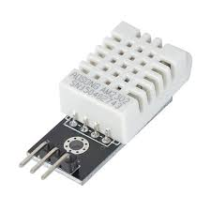

5.MQ7

This is a simple to use Carbon Monoxide sensor, suitable for sensing CO concentrations in air.

MQ7 can detect CO gas concentrations anywhere from 10 to 500ppm

This sensor has a high sensitivity and fast response time.

The sensor’s output is an analogy resistance.

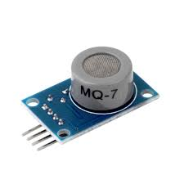

6.IONIZER CIRCUIT

An air ionizer or as some may refer it as a room ionizer is basically a device or electronic circuit which is designed for generating voltage at the level of kilovolts for implementing the said ionizing effects.

13

The high voltage that is generated from an ionizer is tuned for generating a negative voltage, at around minus 2 kV. This high negative voltage is allowed to get terminated over an open-ended sharp conductor tip or point that is sharply carved.

When the voltage reaches at this sharp point, it tends to continue its forward motion and gets shot or released into the air in the form of negatively charged ions.

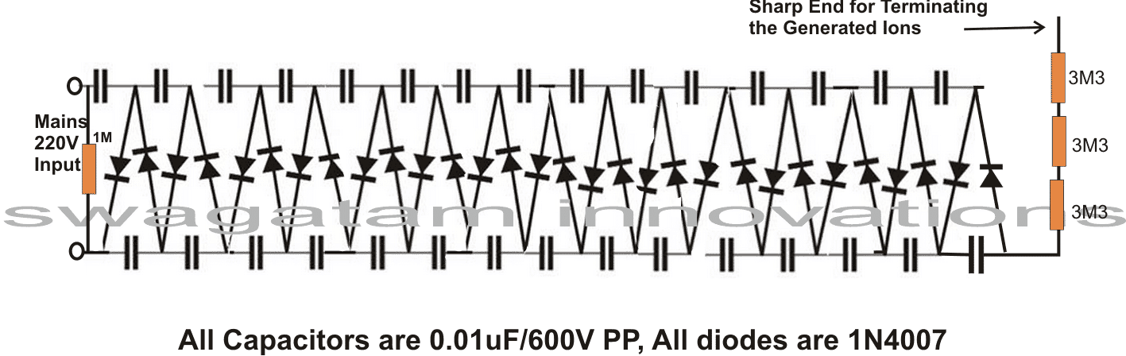

12

CIRCUIT DIAGRAM

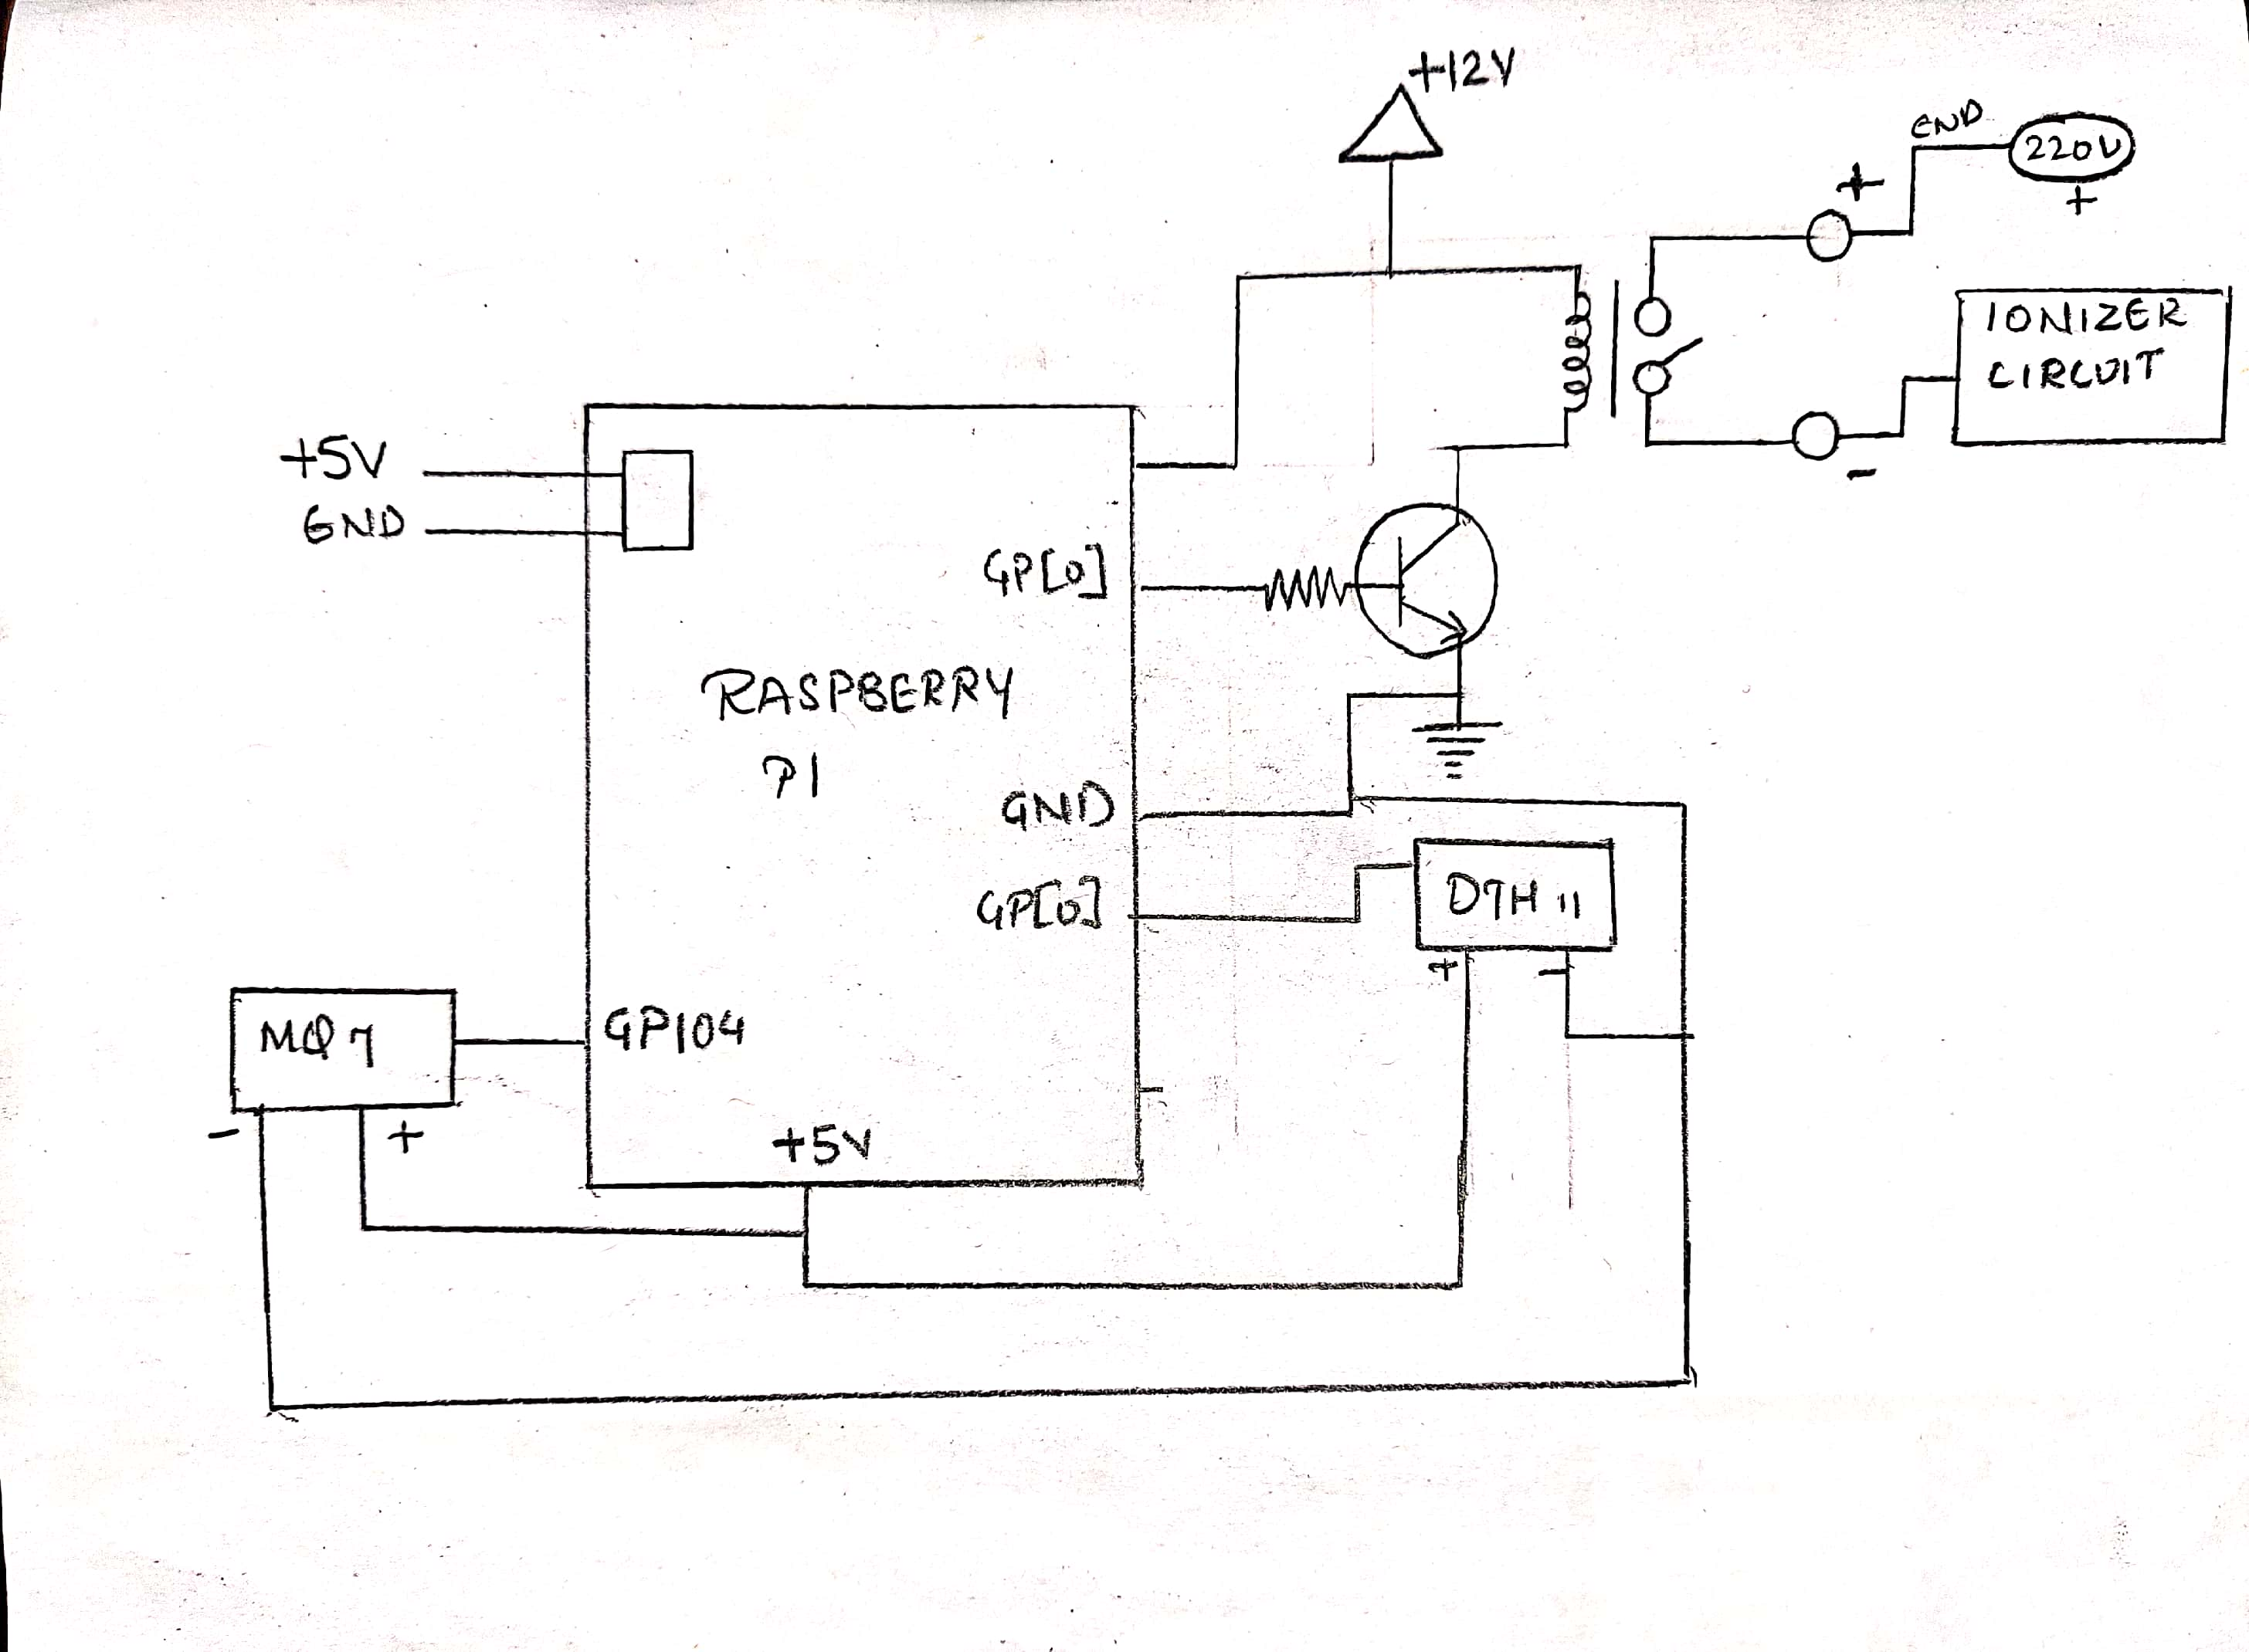

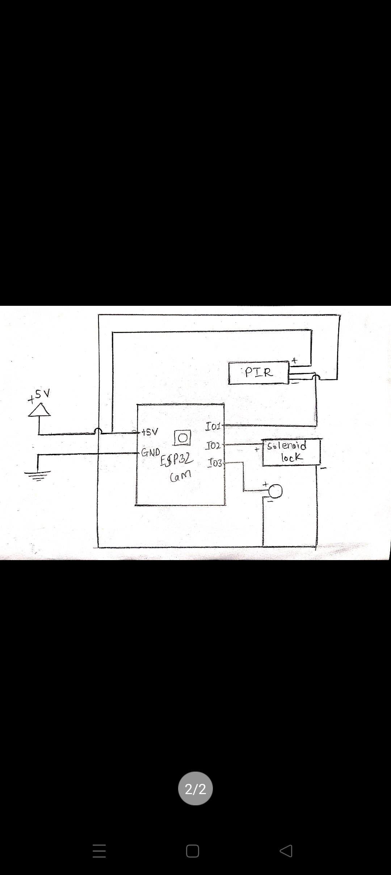

15

SOFTWARE DESCRIPTION

16

FLOWCHART

START

INITIALIZTION

PIR SENSOR

CAMERA ACTIVATION

CAPTURE IMAGE N SENDS TO AWS

COMPARE

DOOR UNLOCK AND MSG TO TELEGRAM CHATBOT

ALERT ON TELEGRAM CHAT BOT

USER CHOICE

LOCK DOOR

NO

NO

YES

YES

17

START

INPUT FROM

DHT11 AND MQ7

INITIALIZE

THRESHOLD LIMIT

IONIZATION

MSG TO TELEGRAM BOT

LCD DISPLAY

18

ADVANTAGES & APPLICATIONS

ADVANTAGES

* There is no need of human-to-human interface.
* Environmental damage from air pollution is reduced.
* Monitoring home security and devices using Telegram Bot.
* This project helps in understanding of IoT sensors and security purpose.
* Enhanced safety within your business premise.
* Quality monitoring of high areas.
* Need in Health care systems
* Need in Indoor and Outdoor Air quality system.

APPLICATIONS

* We can control devices from long distance; thus, it gives ease of access.
* Faster operation and efficient.
* This can be used in smart cities, and offices.
* This system can also be used in Hotels, IT parks.
* Air quality monitor uses when dust is generated on jobsites or in the event of a natural disasters.

19

CONCLUSION

18

20

FUTURE SCOPE

* In an intense study of Internet of Things, we came to know that IoT is highly involved for smart applications.
* We can connect it with Home Automation System.
* In future we can connect Alexa with Telegram for more security purpose and including upcoming 5Gs technologies will created more opportunities.
* Hologram can be also induced in this project for wireless communication and high security.
* For security surveillance we can connect it with TV.

21

REFERENCE

* Ishan Krishna, K. Lavanya, “Intelligent Home Automation System using Bit Voicer”, 11th International Conference on Intelligent Systems and Control, 2017.
* Ramón Alcarria, Diego Martín de Andrés, “A Service-Oriented Monitoring System Based on Rule Evaluation for Home Automation”, IEEE 2016.
* Hattie Clougherty, Alec Brown, Margaret Stonerock, “Home Automation and Personalization through Individual Location Determination”, IEEE 978-1-5386-1828-6/17/$31.00 2017.
* ShibliNisar, Muhammad Asadullah, “Home Automation Using Spoken Pashto Digits Recognition”, IEEE 978-1-5090-3310-2/17/$3\.00 2017.
* Sukhen Das, souvikghosh, RishirajSarker, “A Bluetooth Based Sophisticated Home Automation System Using Smartphone”, international conference on intelligent power and instrumentation, 2016.
* Juan Carlos de Oliveira, Danilo Henrique Santos,” Chatting with Arduino Platform through Telegram Bot”, IEEE International Symposium on Consumer Electronics, 2016.
* Vedan rattan vasta , Gopal Singh, “Raspberry Pi based Implementation of Internet of Things using Mobile Messaging Application - „Telegram‟”, International Journal of Computer Applications (0975 –8887), Volume 125 – No.12, July 2016.

22

WORKPLAN

23

|  |  |  |
| --- | --- | --- |
| SR.NO | Project Detail | Dates |
| 1. | Group Discussion | 5TH August |
| 2. | Topic Discussion | 12th August |
| 3. | Brief Topic Discussion | 26th August |
| 2. | Topic Finalized | 23rd and 22th September |
| 5. | 1st Project Review | 27th September |
| 6. | 2nd Project Review | 13th September |
| 7. | 3rd Project Review |  |
| 8. | 3rd Project Review |  |

21